Quiz Analysis
Student Name: VARSHINI N
USN: 1VI23CD059
Course: Data Visualization/ Tableau Assignment
Tool Used: Tableau Desktop/ Tableau Public
Dataset Used: Superstore_Canada.xls

Step by Step Implementation:
Steps: Import the Data
- Open Tableau Desktop
- Click "Connect to Data" → "Microsoft Excel"
- Navigate to and select Superstore_Canada.xls
- Drag the "Orders" sheet to the canvas
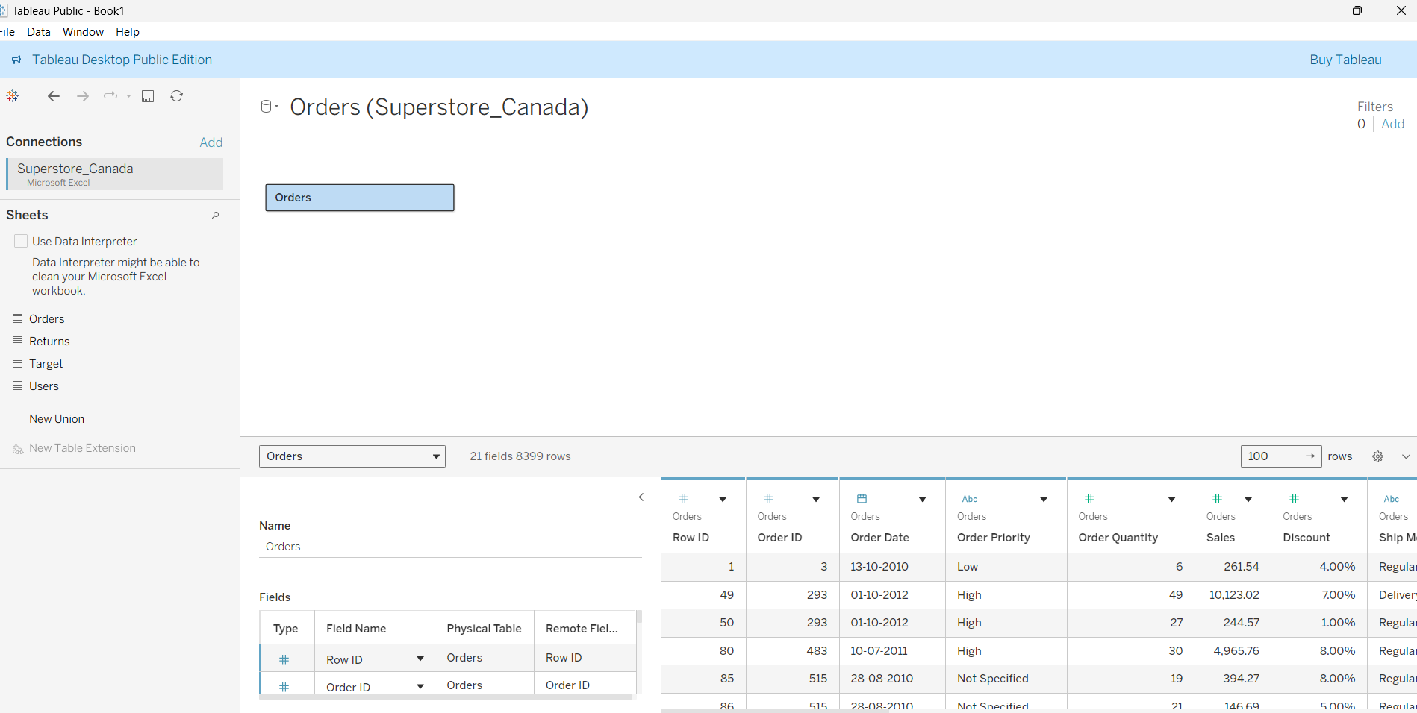
- Click "Sheet 1" to start your analysis
Question : Quiz 1
Import – Superstore_Canada.xls (Sheet – Orders) and answer the following questions:

- What is the total sales of the store?
Steps:
- In Sheet 1, drag Sales field to the Text shelf in Marks card
- Tableau will automatically sum the values
- You should see the total: 14,915,601
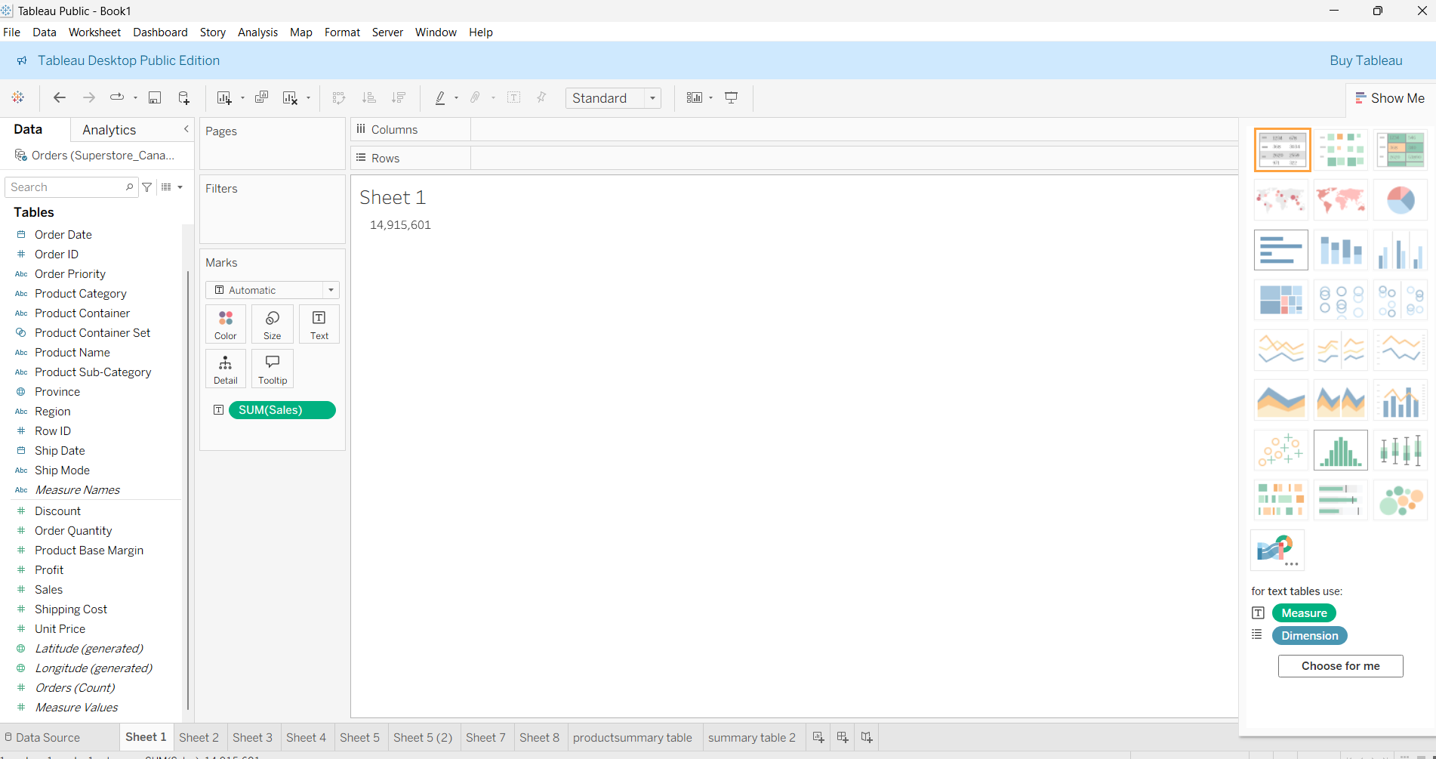

B.What is the total sales of product category = “Furniture”?
Steps:
- Create a new sheet (right-click on Sheet 1 → Duplicate or click new worksheet icon)
- Drag Category to Filters shelf
- In the filter dialog, select only "Furniture"
- Drag Sales to Text shelf
- Result should be: 5,178,591
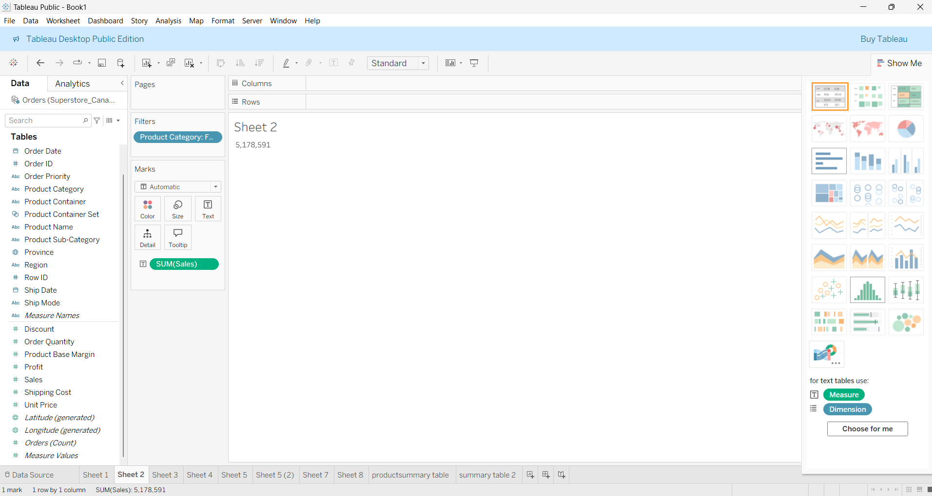
C .What is the total sales of product category = “Furniture” sold to Customer Segment = “Corporate”?
Steps:
- Create a new sheet
- Drag Category to Filters → Select "Furniture"
- Drag Segment to Filters → Select "Corporate"
- Drag Sales to Text shelf
- Result should be: 1,862,841
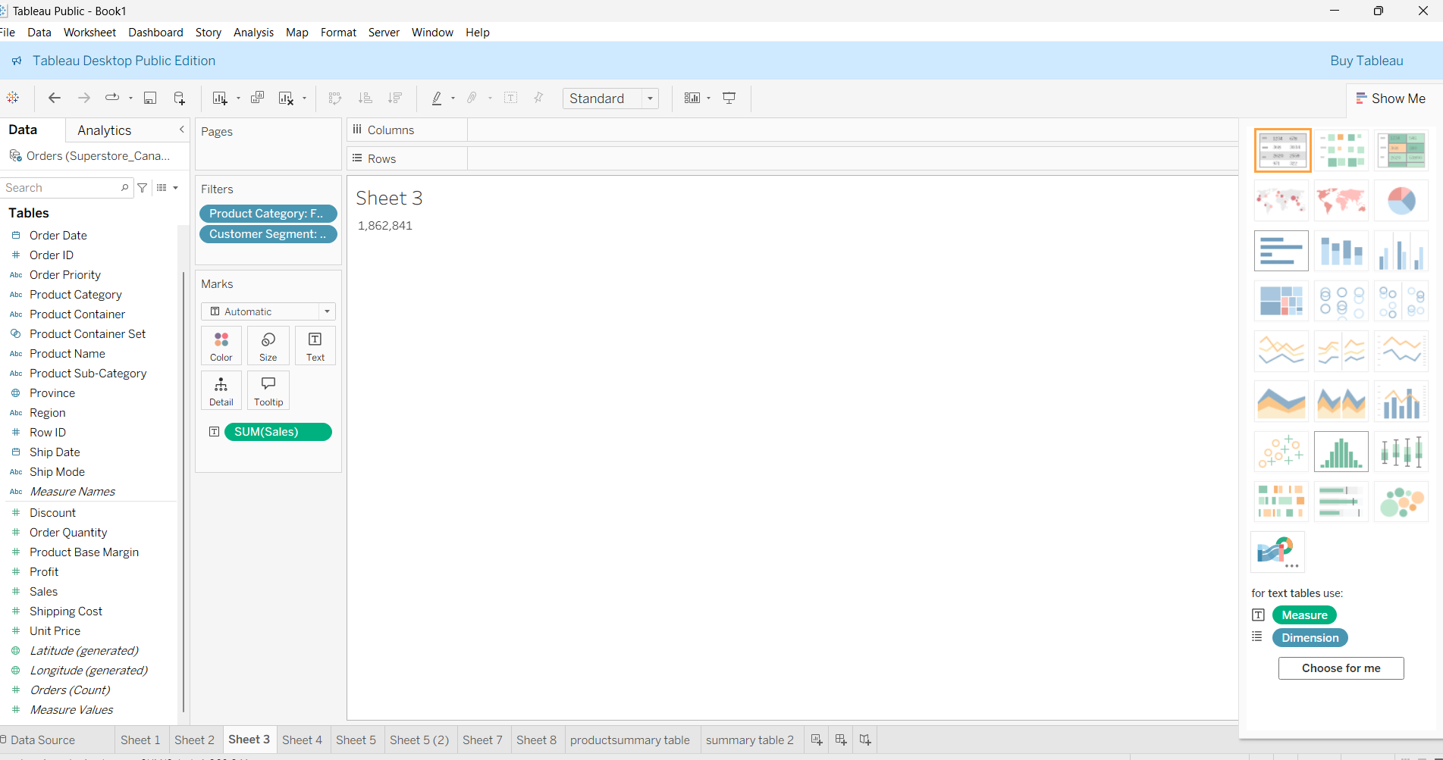

D. Set the default number format of Discount to percentage with 2 decimal places
Steps:
- In the Data pane (left side), find the Discount field
- Right-click on Discount → Default Properties → Number Format
- Select "Percentage" from the dropdown
- Set Decimal places to 2
- Click OK

E. Find average discount on each order priority. Which order priority has highest average discount?
Steps:
- Create a new sheet
- Drag Order Priority to Rows
- Drag Discount to Columns
- Click on the SUM(Discount) pill → Change to AVG(Discount)
- Right-click on the AVG(Discount) axis → Format → Numbers → Percentage with 2 decimals
- To see values clearly: Drag Discount to Label in Marks card (ensure it's AVG)
- Sort by clicking the descending sort icon
- Answer: Low priority has highest at 5.04%
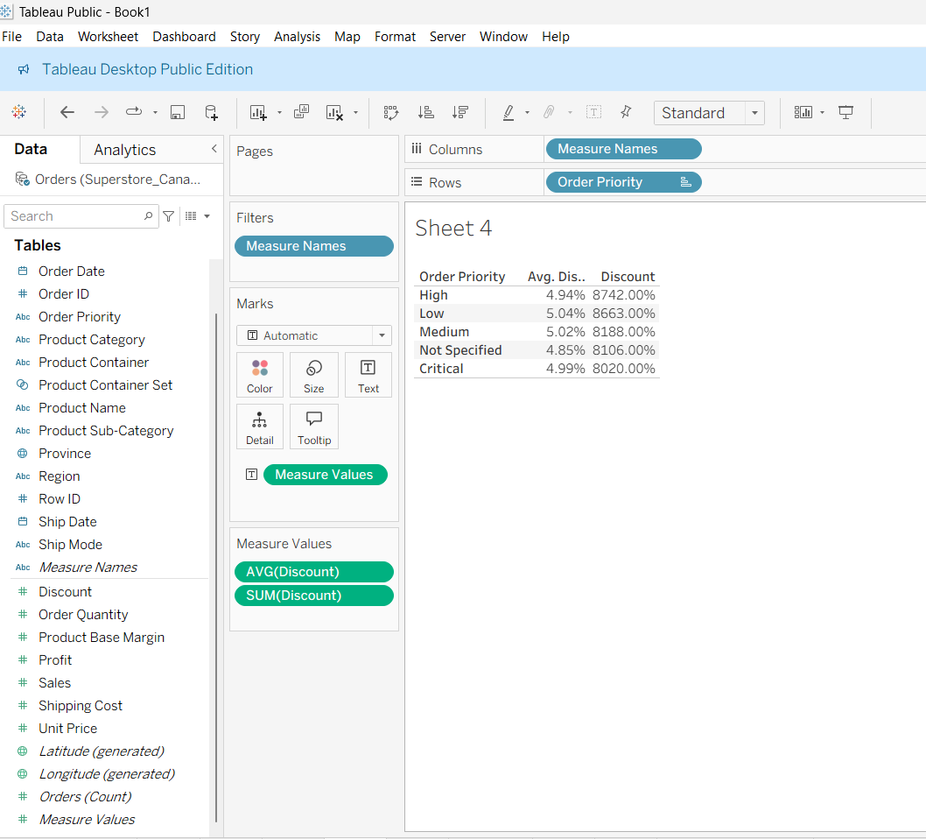
Quiz 2:
Import – Superstore_Canada.csv and answer the following questions:
- For Product Container = “Large Box” which Ship Mode has lowest average shipping cost?
Steps:
- Create a new sheet
- Drag Product Container to Filters → Select "Large Box"
- Drag Ship Mode to Rows
- Drag Shipping Cost to Columns
- Change SUM to AVG (click on pill → Measure → Average)
- Sort ascending to find lowest
- Answer: Express Air
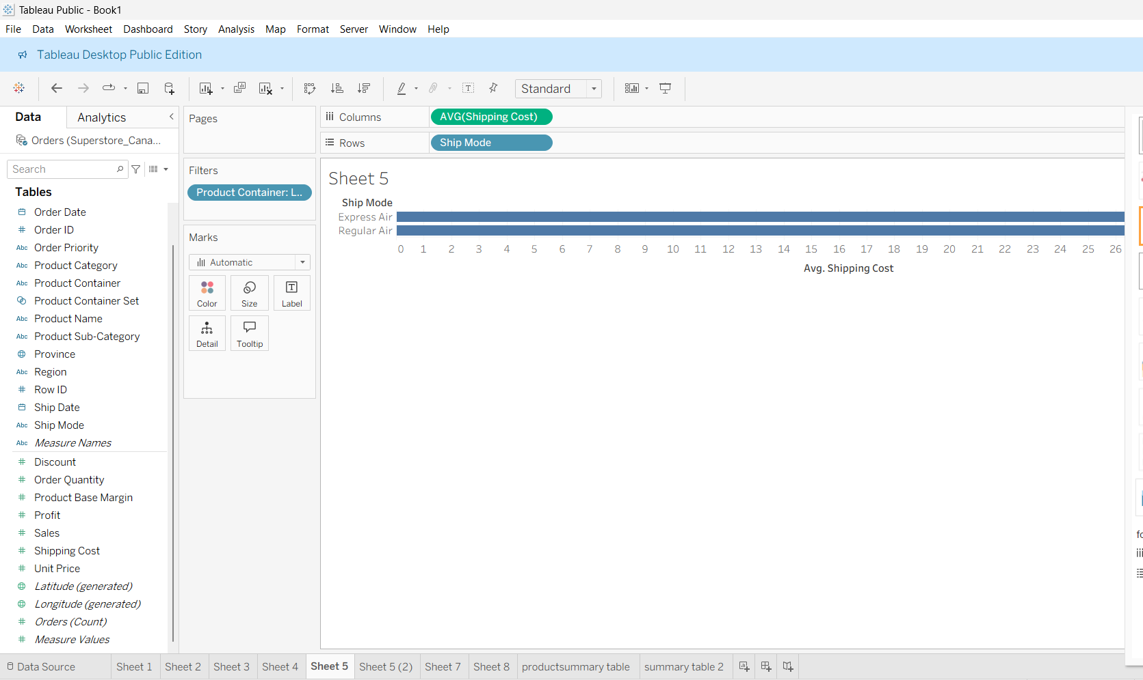
B. For Product Container = “Medium Box” which Ship Mode has lowest average shipping cost?
Steps:
- Duplicate previous sheet
- Change filter: Product Container → Select "Medium Box"
- Check which Ship Mode has lowest average
- Answer: Regular Air
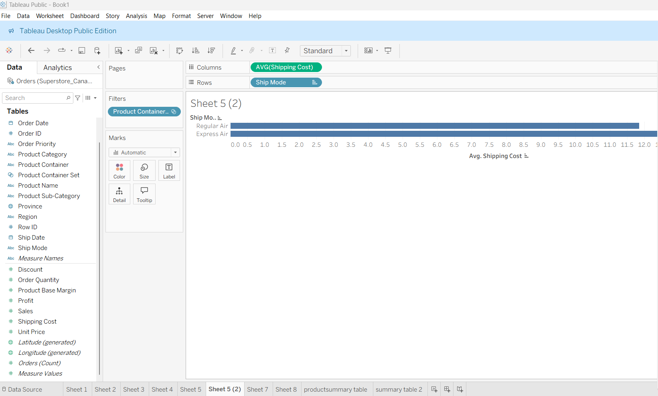
C. Which Ship Mode uses only “Jumbo” sized Product Containers?
Steps:
- Create a new sheet
- Drag Ship Mode to Rows
- Drag Product Container to Columns
- Drag Number of Records (or any measure) to Text
- Look for Ship Mode that has values only in "Jumbo" column
- Answer: Delivery Truck
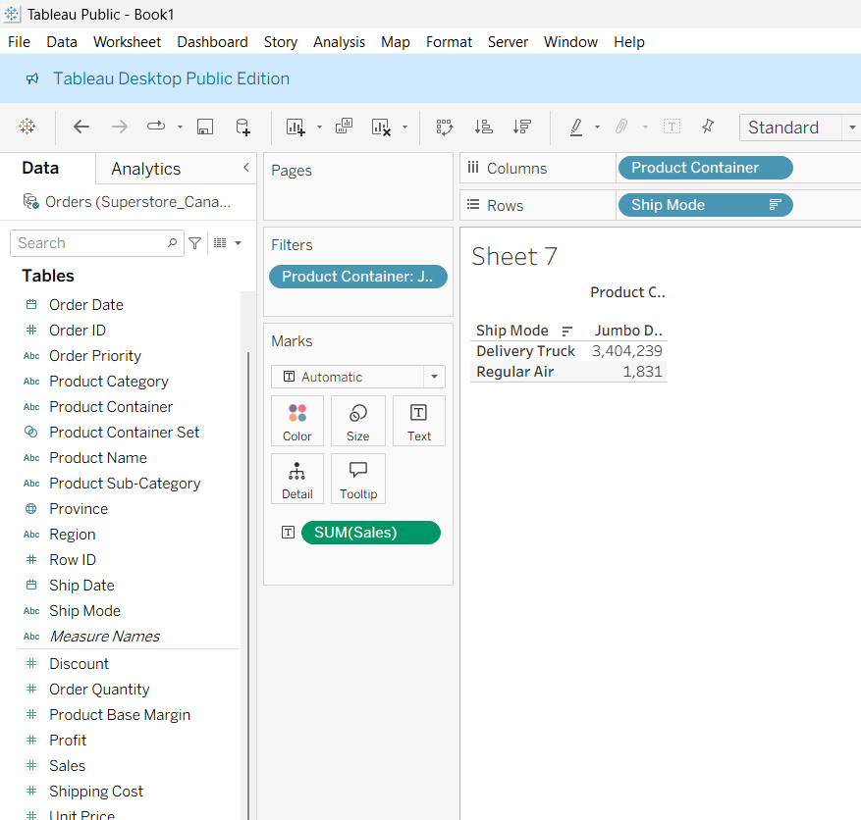

D. Which Ship Mode doesn’t entertain “Jumbo” sized Product Containers?
Steps:
- Use the cross-tab from Question C
- Identify which Ship Mode has no value in "Jumbo" column
- Answer: Express Air
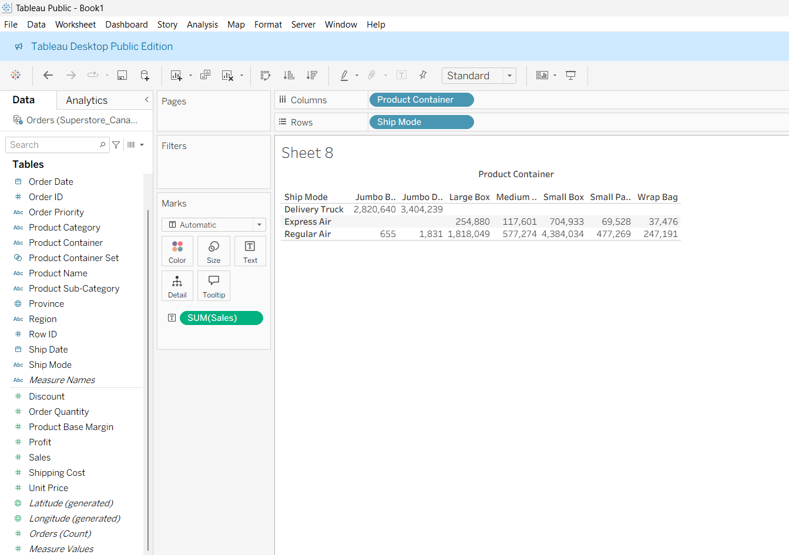

PRODUCT SUMMARY TABLE:
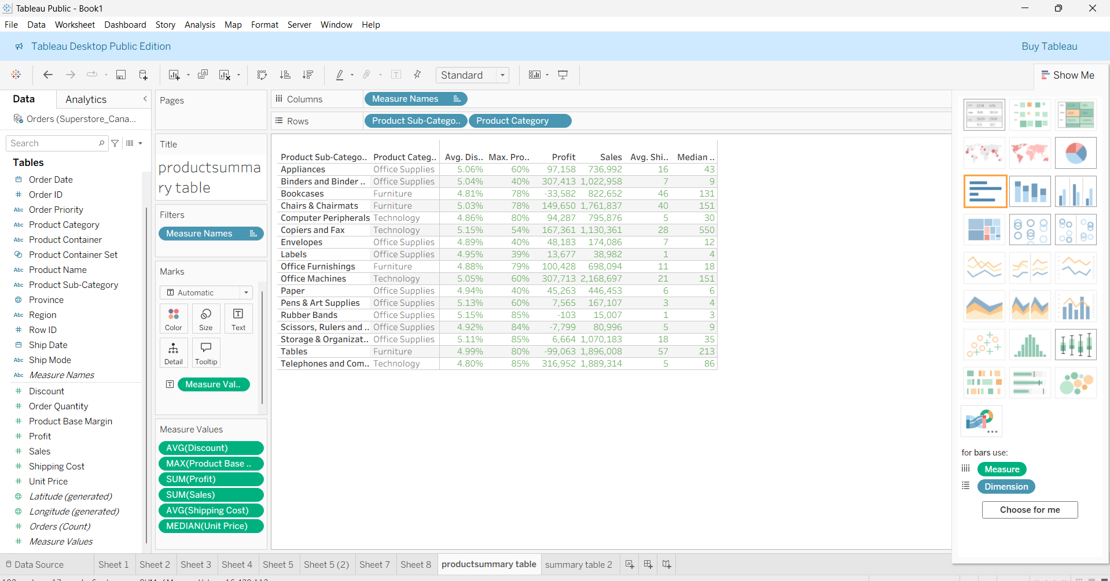

CUSTOMER SEGMENT BY SHIP MODE:
